AWS Subscription capacity

Login to the AWS account which needs to be checked. Search for Service Quotas

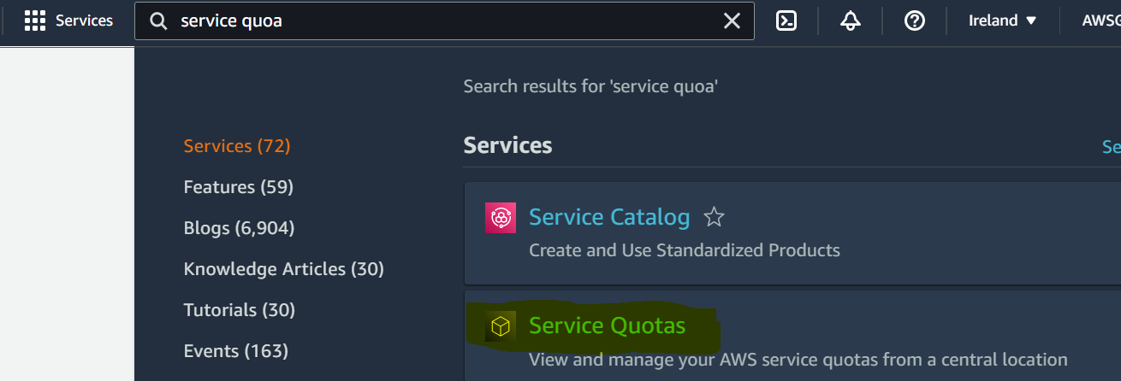

Click on Service quotas and check the services quotas for the particular services.

